Oracle Project Instruction

Bolong Yan

This package has three parts:

SQL files – To create and insert the database in Oracle.

BAT files – To backup and restore the database (need XMAPP support)

DOC file – Readme file

Part I : Create and insert for oracle

Before we start using my oracle database, first of all, edit the create.sql file. Change the system password to your system password (e.g. manager).

Then, start the SQL command line.

Type in

@”<file path>/create.sql”

When it successfully works, the screen shows:

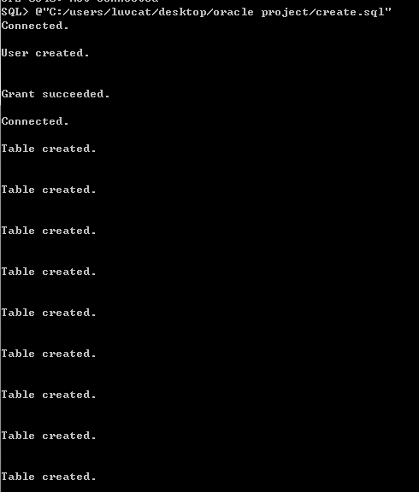

After this, we need insert the data.

Type in

@”<file path>/insert.sql”

When it successfully works, the screen shows:

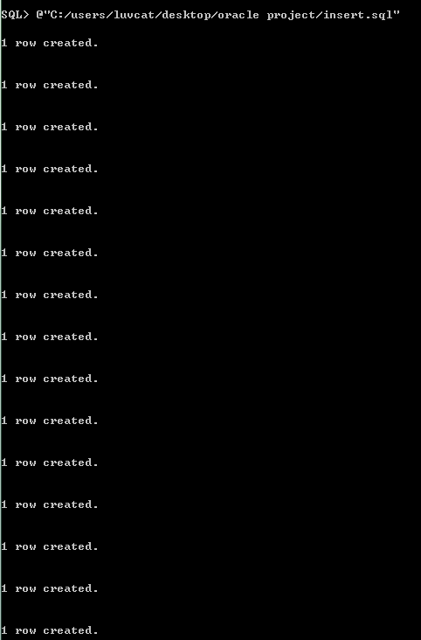

So far, we have already created our oracle database.

Part II: Backup and restore database

We are using Bat files for backup and restore our database.

Just simply run the bat file in command line.